**Requirement Gathering and Analysis Phase**

**Solution Architecture**

|  |  |
| --- | --- |
| Date | 12 July 2024 |
| Team ID | SWTID1720068764 |
| Project Name | Book-Store |
| Maximum Marks | 2 Marks |

**Solution Architecture:**

Solution architecture is a complex process – with many sub-processes – that bridges the gap between business problems and technology solutions. Its goals are to:

* Find the best tech solution to solve existing business problems.
* Describe the structure, characteristics, behaviour, and other aspects of the software to project stakeholders.
* Define features, development phases, and solution requirements.
* Provide specifications according to which the solution is defined, managed, and delivered.

The Book Nest website is made using the MERN full stack, which is used by customers to sell various kinds of books. Also the vendors and the admins can see the real-time information about the books in the website and the sold book’s information.

The below diagram is the solution architecture of the BookNest website that tells us about the code that is used for the making of the application and what each part of the code does in order to make the website complete.

Each part of the solution architecture diagram holds utmost importance to make the application/website usable. Solution architecture is a systematic way of designing a solution that meets a business's needs and goals. Solution Architecture helps developers define the requirements and strategies needed to implement a software solution.

Here is the Solution Architecture Diagram for the BookNest website:

**Solution Architecture Diagram:**

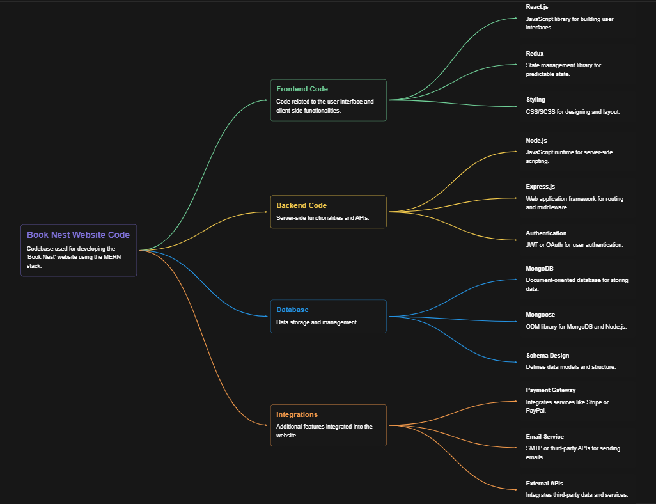

Figure 1: Architecture and data flow of the BookNest application

**Reference:** [**https://aws.amazon.com/blogs/industries/voice-applications-in-clinical-research-powered-by-ai-on-aws-part-1-architecture-and-design-considerations/**](https://aws.amazon.com/blogs/industries/voice-applications-in-clinical-research-powered-by-ai-on-aws-part-1-architecture-and-design-considerations/)